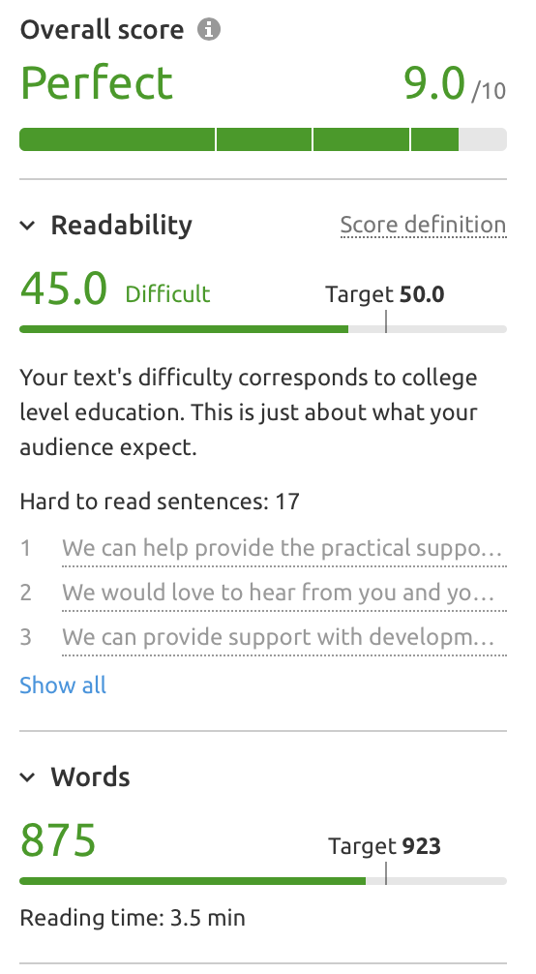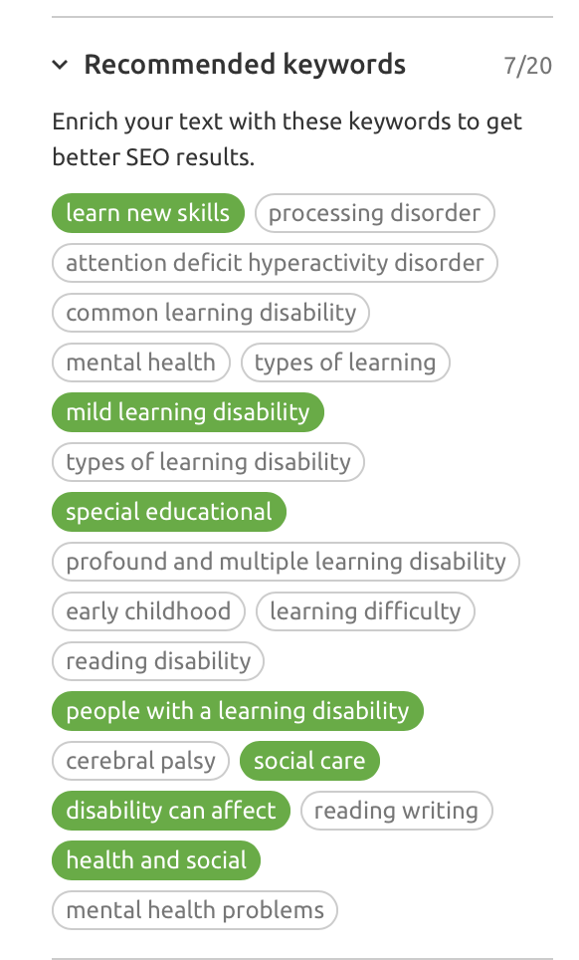

*Learning Disab* *ility (9,900 – 78%)*

*Learning Disabilities (9,900 – 77%)*

**LEARNING DISABILITY SUPPORT**

We often take for granted the ability to go shopping, have a walk in the park or catch up with friends. But, for people with a profound or moderate learning disability, these every day activities can often seem beyond their reach. This does not need to be the case.

Our team of experienced and caring Support Workers can make a real difference to someone’s life, regardless of the severity of their disability. We understand that life for every person living with a learning disability is different – now two people, or their needs, are the same so the support we provide reflects this. Through a dedicated support plan that is unique to the person we are supporting, we will be able to help them overcome significant barriers and therefore lead a fulfilling and active life.

The wishes of those we support will always come first as we work with them to help them accomplish their goals and ambitions while leading an independent life. With an emphasis on ‘support not care’, the focus will be on ‘how can we make this happen safely’ rather than ‘we can’t do this’.

It is estimated that around 1.5million people in the UK have a learning disability of some sort, with up to 350,000 of these deemed to have a profound, or severe, learning disability. Many of these also share other conditions such as Down Syndrome or Autism. Traditionally, day to day support has been provided by family members, sometimes at great emotional cost, but this no longer needs to be the case.

We can offer day to day support, meaning people with a learning disability no longer feel they are reliant on family. This can lead to greater independence, a more active lifestyle and a wider social circle. We can provide support with development, social and communication skills, and any other needs that may occur as a result of not only their learning disability, but also any other disabilities they may have, regardless of how complex these may be.

As a parent of a young person or adult living with a learning disability, you may sometimes feel overwhelmed by the support you are providing or the process of transition from Child to Adult Services. We can help provide the practical support that your son or daughter needs at all times so that you can concentrate on and enjoy simply being their parent in the knowledge that their physical needs are being supported by people with a wealth of experience and training in their field.

We would love to hear from you and your son or daughter so that we can learn all about them and to discover how we can help to support them to achieve everything they want to and become the person they want to be.

**WHAT IS A LEARNING DISABILITY?**

A learning disability affects the way that someone can understand and process information and how they are able to communicate to others. This means that they can have difficulty in understanding information or instructions, learning new skills, coping independently, or expressing their wishes.

A learning disability is usually diagnosed in childhood. Depending on the severity of the learning disability, the level of support required varies greatly. Often, the more severe learning disabilities are present alongside other disabilities or conditions.

Children and young people with learning disabilities could also have Special Educational Needs (SENs) and require additional support at school. Some children with a learning disability can be adequately supported to attend mainstream school, while others may attend a special school more suited to their needs.

Sometimes a cause can be identified for the presence of a learning disability, such as developmental factors, as a result of another disability, or damage to the brain at birth. In many cases though, there is no apparent cause. Learning disabilities tend to be permeant and in most cases, there is no treatment. This does not mean that people with a learning disability cannot lead an independent and fulfilling life though. If adequately supported they can continue to achieve, and exceed, personal aspirations and goals.

**SEVERITY OF LEARNING DISABILITIES**

Learning disabilities are generally categorised as mild, moderate or severe (profound).

* Mild – a person with a mild learning disability will usually be able to lead an independent life but may take a bit longer than their peers to learn new skills. They will probably have learned coping mechanisms to help them learn more effectively, making their disability less obvious to others.
* Moderate – a person living with a moderate learning disability may require some support to live independently. This support may include help managing money, support with tasks such as housework and help to access community services.
* Severe (profound) – a person living with a profound learning disability may be reliant on others for things like personal care and to undertake physical tasks and may have difficulty communicating their wishes.

**WHAT IS TRANSITION**

Services for young people are provided by Children’s Health and Social Care Services until the age of 18. Between the ages of 16-18 they will undertake the transition to Adult Services. Planning for this transition should start as early as 13 years old (age 9 at school).

The NHS provides more information about [the transition process](https://www.nhs.uk/conditions/social-care-and-support-guide/caring-for-children-and-young-people/moving-from-childrens-social-care-to-adults-social-care/).